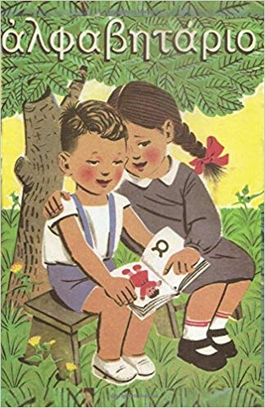

GREEK SCHOOL ENROLMENTS HAVE COMMENCED
Wednesday, 7th January 2026
until
Friday, 30th January 2026

Place: The Greek Orthodox Parish and Community of Kogarah Church Office
20 Belgrave Street,
Kogarah 2217

Monday - Friday
10:00 a.m. – 3:00 p.m.

Telephone: (02)9587 5945

Email: schools@kogarahgreekorthodox.org.au

All Enrolments and Payments Will Be Processed at the Church Office.

Classes commence Monday, 9th February 2026

Open Days for Enrolments:
Saturday, 31 January 2026 10:00 a.m. - 12:00 noon
Saturday, 7 February 2026, 10:00 a.m. – 12:00 noon
Level 1 Hermes Lounge (next to the church)

